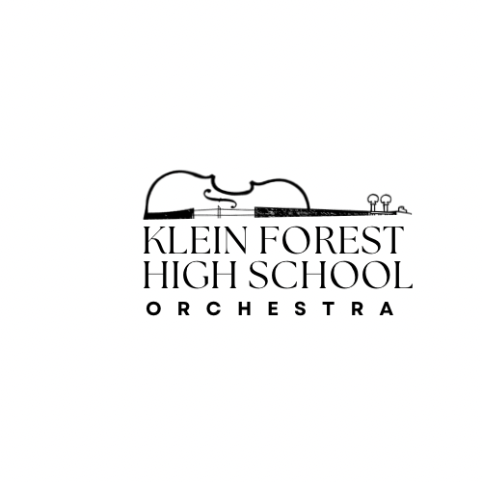
Klein Forest High School Orchestra Class Representative
Position Description:
The Orchestra Class Representative serves as a positive leader and liaison between their orchestra class and the orchestra directors. Class Reps help strengthen communication, support classroom culture, and assist in creating an encouraging, organized, and community-focused orchestra environment. They model professionalism, teamwork, and pride in the program while helping ensure that every student feels welcomed and informed.
Primary Duties & Responsibilities
Communication & Leadership
- Act as the voice of your orchestra class by sharing questions, concerns, and ideas with the directors or officers.
- Help relay important announcements, reminders, and event details to classmates.
- Assist new students by helping them understand routines, expectations, and resources.
Classroom Support
- Help maintain a positive, respectful rehearsal environment.
- Encourage classmates to stay on task, follow procedures, and uphold orchestra standards.
- Support instrument storage room organization and locker area expectations.
Event Assistance
- Volunteer at orchestra events (concerts, socials, fundraisers, trips) as needed.
- Help with setting up and resetting the orchestra room before/after rehearsals or events.
- Assist directors and student leaders with distributing programs, managing sign-ins, or guiding guests.
Community & Culture Building
- Lead by example with excellent attendance, preparation, and attitude.
- Welcome and support new orchestra members, helping build a friendly and inclusive environment.
- Encourage class participation in spirit days, fundraisers, and program-wide activities.
Accountability
- Maintain strong personal musicianship, practice habits, and professionalism.
- Demonstrate reliability — completing tasks on time and being present when reps are needed.
- Represent the orchestra program with pride on and off campus.

🎻 KLEIN FOREST HIGH SCHOOL ORCHESTRA CLASS REPRESENTATIVE — APPLICATION FORM & CONTRACT / COMMITMENT AGREEMENT
Name: ____________________________________________
Grade: ___________
Class Period / Ensemble: ___________________________
Student Email: _____________________________________
Parent/Guardian Name: ______________________________
Short Answer Questions
(Please answer clearly and thoughtfully.)
- Why do you want to be an Orchestra Class Representative?

- What strengths or leadership qualities would you bring to this role?

- Describe a time you showed responsibility, initiative, or helped build a positive classroom or team environment.

- How will you help keep your class informed, organized, and involved in orchestra events?

- Are you willing to volunteer for concerts, events, and fundraising activities when needed?
☐ Yes ☐ No
If yes, list any prior volunteer experience (optional):

Student Signature
I certify that all information above is true and that I understand the expectations of being a Class Representative.
Student Signature: ___________________________ Date: ___________

🎻 ORCHESTRA CLASS REPRESENTATIVE — CONTRACT / COMMITMENT AGREEMENT
As an Orchestra Class Representative, I agree to uphold the following responsibilities and expectations throughout the school year:

Student:
I understand and agree to fulfill the duties of an Orchestra Class Representative to the best of my ability. I certify that all information provided is true and that I understand the expectations of being a Class Representative.

Student Signature: _____________________________ Date: ___________

Parent/Guardian:
I support my student in fulfilling these responsibilities and understand the expectations of this position.

Parent/Guardian Signature: ______________________ Date: ___________
Director Approval: ______________________________ Date: ___________

